|  |  |
| --- | --- |
|  | **TASK 6 Implement various text file operations.**  **6.a**  In a famous tech firm, an employee is asked **to copy the contents of N no.of files to another N no. of files**. Fortunately, the employee has good knowledge in python scripting. So he plans to automate the copy operation by creating a copy function using python file handling operations. Assume you are that employee and implement the copy function to achieve the task.  Example:  Input:  ‘Asdfghjk’  File 1: (write contents from input to file 1)  Asdfghjk  Output: (copy the contents of file 1 to file 2)  File 2:  Asdfghjk  **PROGRAM**  def copy_files(file_paths):  for file_path in file_paths:  if os.path.exists(file_path):  with open(file_path, 'r') as original_file:  original_content = original_file.read()  copy_file_path = file_path.split('.')[0] + '_copy.' + file_path.split('.')[1]  with open(copy_file_path, 'w') as copy_file:  copy_file.write(original_content)  print(f"Contents copied from {file_path} to {copy_file_path} successfully.")  else:  print(f"Error: File '{file_path}' not found.")  # Example usage:  import os  file_list = ['file1.txt', 'file2.txt', 'file3.txt'] # List of file paths  copy_files(file_list)  **OUTPUT** |

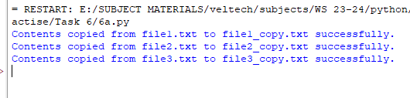

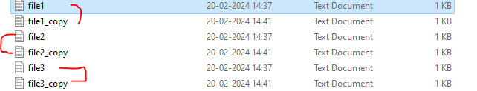

**Problem 6.b:**

You need to write a report containing the details (Name, departments) of the employee in list. Write a Python function that writes this report to a file named employee_report.txt

**Algorithm:**

1. Create Employee Data:
   * Define the function write_employee_report(filename):
     + Create a list employees containing dictionaries, each with "name" and "department" keys for individual employees.
2. Open File for Writing:
   * Open the file specified by filename in write mode using a with statement.
3. Write Employee Data to File:
   * Loop through each employee in the employees list:
     + For each employee, format a string as "Name: {employee['name']}, Department: {employee['department']}".
     + Write the formatted string to the file, followed by a newline character (\n).
4. Execute the Program:
   * Call write_employee_report("employee_report.txt") to write the employee data to the file "employee_report.txt".

**Program 6.2:**

def write_employee_report(filename):

employees = [

{"name": "Alice", "department": "HR"},

{"name": "Bob", "department": "Engineering"},

{"name": "Charlie", "department": "Finance"}

]

with open(filename, "w") as file:

for employee in employees:

line = f"Name: {employee['name']}, Department: {employee['department']}\n"

file.write(line)

# Example usage:

write_employee_report("employee_report.txt")

**output:**

